**Lab Assignment - 6**

1. WAP in PL/SQL to find the sum of two numbers.

**Code** -

declare

a integer;

b integer;

c integer;

begin

a:=:a;

b:=:b;

c:= a+b;

dbms_output.put_line('The sum of ' ||a|| ' and ' ||b|| ' is = '||c);

end;

**Output** -

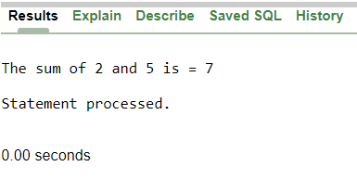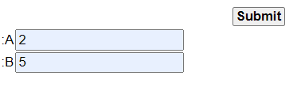

1. WAP in PL/SQL to find whether the given number is odd or even.

**Code** -

declare

a integer;

begin

a:=:a;

if(a mod 2 = 0) then

dbms_output.put_line(a|| ' is even');

else

dbms_output.put_line(a|| ' is odd');

end if;

end;

**Output** -

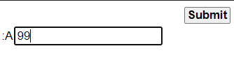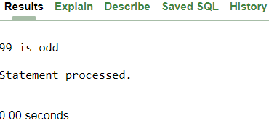3.WAP in PL/SQL to find whether the year is leap or not.

**Code -**

declare

year integer;

begin

year:=:year;

if(year mod 4 = 0 AND year mod 100 <> 0 OR year mod 400 = 0) then

dbms_output.put_line('This ' ||year|| ' is a leap year');

else

dbms_output.put_line('This '||year|| ' is not a leap year');

end if;

end;

**Output**-

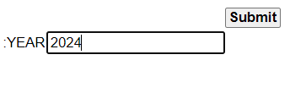 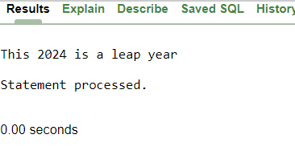 4.WAP in PL/SQL to find the sum of first n numbers.

**Code-**

declare

i integer;

s integer;

n integer;

begin

n:=:n;

s:=0;

for i in 1..n loop

s:=s+i;

end loop;

dbms_output.put_line('Sum = ' ||s);

end;

**Output -**

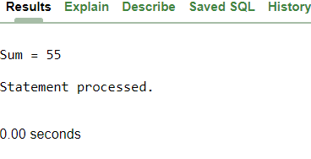

5.WAP in PL/SQL to display first n numbers.

**Code -**

declare

n integer :=:n;

i integer := 1;

begin

while i <= n loop

dbms_output.put_line(i);

i := i + 1;

end loop;

end;

**Output -**

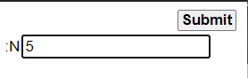

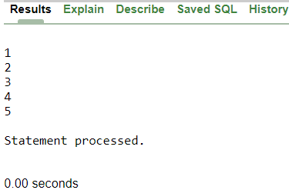

1. WAP in PL/SQL to find the sum of first n odd numbers.

**Code -**

declare

n integer;

a integer := 1;

b integer := 0;

begin

n:=:n;

for i IN 1..n loop

b := b + a;

a := a + 2;

end loop;

dbms_output.put_line('The sum of the first '||n||' odd numbers is: '||b);

end;

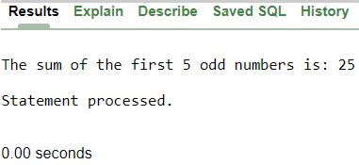**Output -**

1. WAP in PL/SQL to find the sum of first n even numbers.

**Code -**

declare

n integer;

a integer := 2;

b integer := 0;

begin

n:=:n;

for i IN 1..n loop

b := b + a;

a := a + 2;

end loop;

dbms_output.put_line('The sum of the first '||n||' even numbers is: '||b);

end;

**Output -**



1. 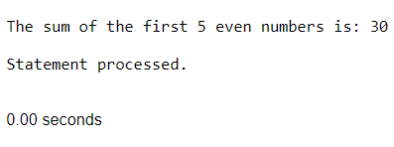WAP in PL/SQL to find the factorial of any number. Number is entered by user during run time.

Code -

declare

n integer;

f integer := 1;

begin

n :=:n;

if n < 0 then

dbms_output.put_line('Factorial is not defined for negative numbers.');

else

for i IN 1..n loop

f := f * i;

end loop;

dbms_output.put_line('Factorial of ' || n || ' is: ' || f);

end if;

end;

**Output -**

